**Configure AmCart Theme in Keycloak**

1. Stop the ***keycloak*** server if running
2. Go to ***keycloak*** installation directory (extracted ZIP directory)
3. Go to ***themes*** folder
4. Extract ***AmCartTheme.zip*** (placed in ***Configuration Files*** folder) in this directory
5. The folder structure should be ***themes*** -> ***AmCartTheme*** -> ***login***
6. Now start the ***keycloak*** server
7. Go to admin console of ***keycloak***
8. Login with ***admin***
9. Select ***ClientAmCartApp*** realm from top left combo box.

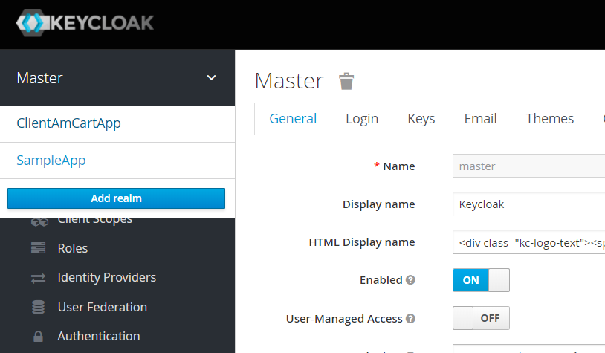

1. Now go to ***Themes*** tab

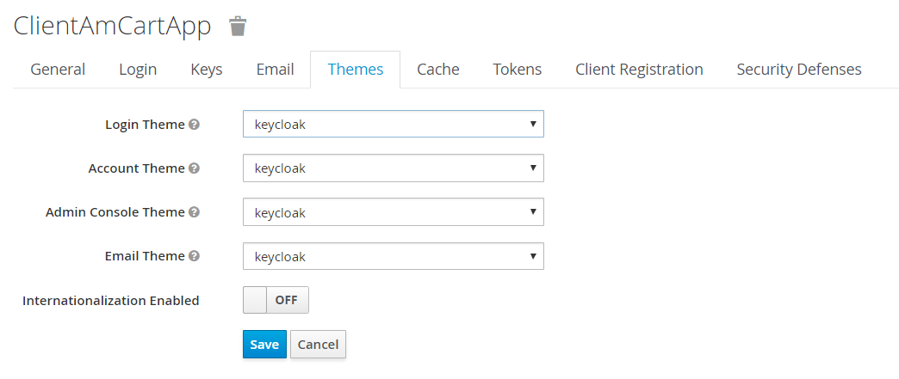

1. Select ***AmCartTheme*** in ***Login Theme*** combo box

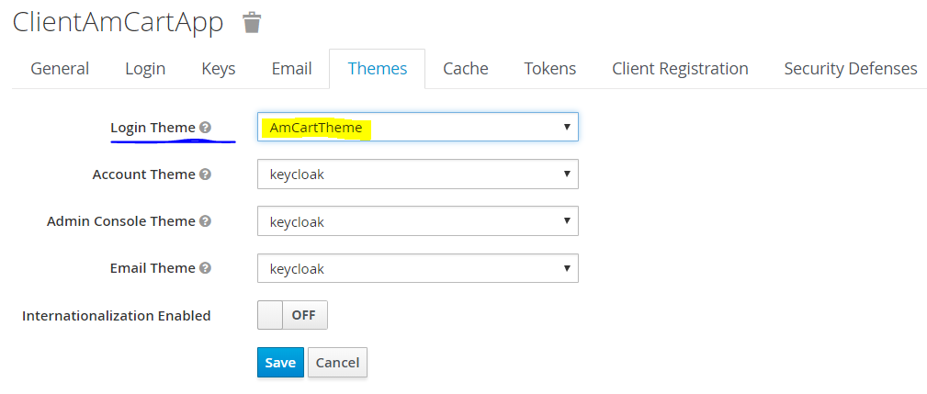

1. Click on ***Save*** button.